AWS Serverless ETL Pipeline

Architecture Diagram
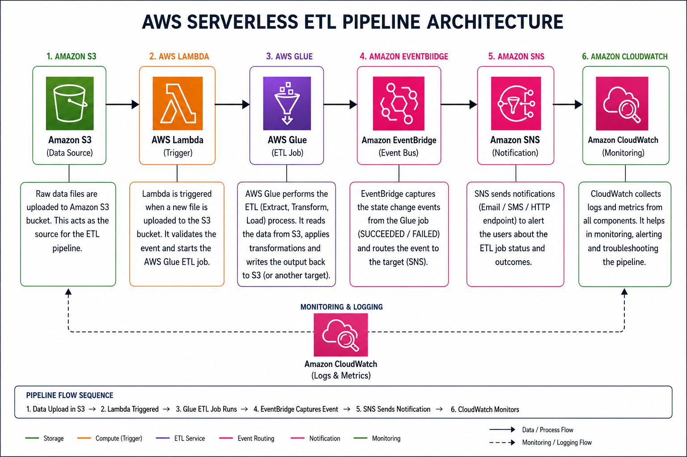
This architecture shows the complete serverless ETL workflow: Amazon S3 stores source files, AWS Lambda is triggered on file upload, AWS Glue performs ETL processing, EventBridge captures job events, SNS sends notifications, and CloudWatch provides monitoring and logging.

Serverless ETL Flow Explanation
1. Data is uploaded into Amazon S3.
2. S3 triggers an AWS Lambda function.
3. Lambda starts an AWS Glue ETL job.
4. EventBridge captures Glue job state changes.
5. SNS sends success/failure notifications.
6. CloudWatch collects logs, metrics, and monitoring data.

